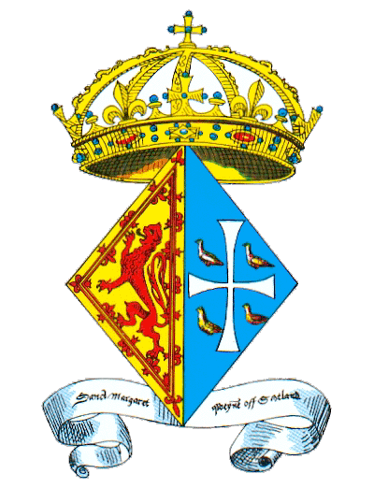 **St Margaret’s Chapel Guild** **Newsletter**

**January 2019 issue 35 *Convenor’s Report***

Dear Margarets

I know 2019 is only a few weeks old, but I would still like to extend my Best Wishes to you all for a Happy and Healthy New Year. I do hope you all had an enjoyable Festive Season.

Judging by the number of letters, cards and emails I received after our St Margaret’s Day Celebrations, in November, I think I can safely say that it was a successful and enjoyable day. Following the many positive comments I received about the Minibus the Guild provided, it is planned that this service will be continued to transport our members from the top of the Esplanade to the Queen Anne Room in the morning, and return to transport our members down again, after our AGM.

I know that many of you would like to join me in thanking Margaret Lynch for the immense amount of work she has carried out in getting the Guild’s website up and running. I do hope that many of you will use the website as much as possible, especially the Member’s Section. This is where items of interest will be displayed. Also, if you have any news you would like to be shown on the Member’s Section please contact Margaret, who will be happy to arrange this. It is particularly nice to have photographs of Flower Arrangements for other members to see.

I do hope many of you saw the new Display Stand/Money Box that the Guild has had commissioned, to replace the existing Money Box, in the Chapel. It sits in the corner beside the Stained Glass Window of St Margaret. The idea of this position is that it will be the first thing visitors see when they enter the Chapel. It was designed and made for us by Grassmarket Community Project, in Oak from Dunfermline Abbey. The design is beautiful and includes small Roundels on each side, which match the Roundels on the Benches.

Being Oak it is exactly the same colour as the Benches the Guild had made for the 1993 anniversary of St Margaret’s Death. We hope that the design will encourage more visitors to the Chapel, to view and purchase more Booklets.

Again my very Best Wishes for 2019.

Yours in Friendship

*Margaret Lindsell*

***Convener***

***Carol Service in the Grand Hall at the Castle***

Margaret Lindsell invited me to attend the Carol Service in the Castle on behalf of the guild and read a Lesson at the service on Thursday 13th December 2018. The service was attended by many offices in the Castle and their families, and the Royal Regimental Band of Scotland accompanied the Singing of the Carols. The Reverend Duncan Macpherson CF, Service Chaplain of 51 Brigade and HQ Scotland, led the service. Regimental departments were represented: Commander of the Garrison, Chair of the Trustees of the Scottish War Memorial, Historic Environmental Scotland, The Soldiers Charity (ABF), Rev Neil Gardner our Patron, and of course St Margaret’s Chapel Guild was represented. It was privilege to read a lesson “The Shepherds and the Angels” St Luke’s 2: 8-21.

At the conclusion of the Carol Service, my husband Paul and I were invited to join the staff enjoying mince pies and a warming cup of Gluhvein. As the sun went down, leaving the castle the city was a sea of twinkling lights with people in the German Market in the Gardens below having fun with lots going on. It was a very enjoyable beginning to the Festive Season.

***Margaret Lynch***

***Fellowship News***

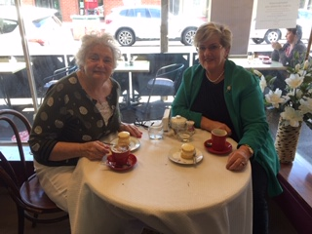**Inaugural meeting of the Australian St Margaret’s Fellowship group.** Margaret Banks (right), who has arranged the flowers in the Chapel when she visited Edinburgh recently and met up with Maggie Craddock (left) for lunch in Melbourne on her return home. Margaret Banks is proudly sporting her St Margaret’s brooch.

Margaret Lynch and her husband are going to Melbourne in February and are planning to meet up with both ladies.

**Also**

**St Margaret’s Episcopal Church in Pennsylvania celebrate St Margaret’s Day**

A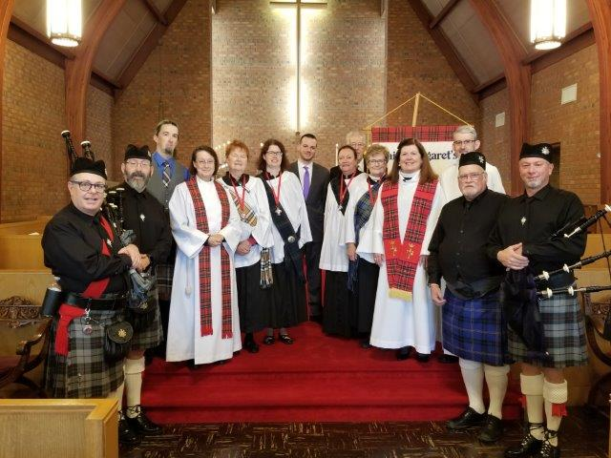fter the Service two drummers and three pipers along with the organ and choir had this photo taken after lunch in the parish hall.

***Hazel M Dunn, Fellowship Secretary***

***Greyfriars Graveyard Walk***

Margaret Marr arranged a very interesting walk in Greyfriars Kirk and Churchyard in September of last year and 10 ladies enjoyed it very much, braving a very blustery day. Margaret would like to arrange another walk, in better weather, and so we are looking at April as a possible time, since the Church is open then. The date to be arranged, so please contact me if you interested and would like to go on the list. [margaret@lynchdudes.net](mailto:margaret@lynchdudes.net).

***A trip to Dunfermline Abbey and Tour***

One of our new members Nan Margaret Allen who lives in Dunfermline and works in the Abbey shop, is also a guide, has offered to take a group on tour around the Abbey. The best time for this event would be later on in the Spring, perhaps May, but as yet, we do not have a date for this tour. If you are interested in this tour please send me an email expressing your interest and I will add you to the list. It has been suggested that we could travel to Dunfermline by bus and it would be a short walk to the Abbey. We could arrange a lunch too!

***New Website LIVE***

The new website is now up and running and I am aware that we need to edit it and remove some of the older photos. Now we have more news and articles, I will be suggesting some changes thanks to those of you who sent feedback. Can I remind the ladies who are doing the flowers in the Chapel to take a photo and send it to me so that it can be entered into the ‘gallery of flowers’. To access the Website type in **stmargaretschapel.com** into the browser, this will bring you to the main page. To access the Members Section key in the password is **10daisy93,** as before. You will see the list of items on the right hand side of the page under Members.

***The New Constitution***

I have been asked to update The Constitution for SMCG to take account of the legal changes in the law. I prepared a draft paper which I took to the Executive Committee Meeting on 14th January and this was discussed at great length. As a result of the comments there, I will now prepare an updated draft which will hopefully comply with best practice and governance for the OSRC Regulations. We hope to have a final Draft ready for the AGM in November.

***Sarah M C James***

***St Margaret’s Chapel Guild***

***Secretary***

***The New Audio Guide for the Castle***

The new Castle audio guide that visitors to the Castle can hire has not been updated for 20 years, so Historic Environment Scotland decided it was due an overhaul.  They signed up a narrator to provide the historical and practical information required, but they wished to add a little local colour to the project.  They wanted to interview people from groups associated with the Castle.  These individuals would provide personal anecdotes and insights into the work they do.  The Guild was approached to field someone to talk about St Margaret, the Chapel and the Guild.  I was lucky enough to be free on the date they wished to do the recording, and I spent a very happy 30 minutes or so waxing lyrical about who we are, and what we do.  They did tell me that my pearls of wisdom would be edited to 4 or 5 minutes, so I look forward to hearing what I said when the new guide is produced!

***Hazel (lucky to be a middle Margaret) Dunn***

***Monthly Flower Ladies***

**A BIG THANK YOU** to all the flower ladies and the money collectors who have braved the winter weather and the dark early mornings to go to the Chapel with their flowers. It is no mean feat! Hopefully we are coming to the end of the dark mornings, at least and spring is just round the corner.

***The Dome Coffee Mornings***

Remember the coffee mornings in The Dome, George Street, Edinburgh are at 10.30 on 16th of each month. Come along and catch up with ‘Margaret’ friends for a coffee and chat. When the 16th of the month lands on a Sunday we meet on Mondays. The next Newsletter will be at the end of June 2019. If you have any articles or stories of interest to the Guild, please send them to me at [margaret@lynchdudes.net](mailto:margaret@lynchdudes.net). Brooches and earrings are available from Margaret Ann Crawford, our Treasurer. You can also contact her by email: mac@LyleCrawford.co.uk.